Carolinas Communication Association
2025 Business Meeting & Awards Ceremony
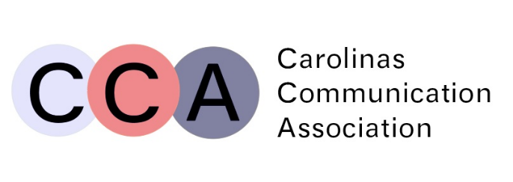
- Call to Order
- Approval of 2024 Meeting Minutes
- Officer Reports
  - Camille Lewis, President
  - Dean Farmer, Vice President
  - Wanda Fenimore, Second Vice President
  - Jasmine Corbett-Warren, Secretary
  - Michaela D. E. Meyer, Journal Editor
  - Carol Leeman, Treasurer
  - Jenni Simon, Immediate Past President
  - Jason Munsell, Executive Director
  - Elena Martinez-Vidal, Web Manager
- Committee Reports
- Program Committee
- Ways and Means
- Betty Joe Welch Award Committee
  - Thanks to:
    - Glovicki, Peter
    - Cuny, Kim
    - McArthur, John A.
- Resolutions Committee
- Nominations Committee
  - Thank you to:
    - Simon, Jenni
    - Akkoor, Chitra
    - Grano, Dan
- Pombo Early Career Teaching Award Committee
  - Thank you to:
    - Aksoy, Ahmet
    - Russell, Vincent
    - Morris, David
- Lloyd Rohler Career Teaching Award Committee
  - Thank you to:
    - Jamie Litty, University of North Carolina at Pembroke
    - Jason Black, University of North Carolina at Charlotte
    - Max Dosser, Vanderbilt University
- Old Business
- Any old business

- New Business
- Election of next Second Vice President of CCA
  - Kim Cuny
- Election of Treasurer
  - Jenny Southard
- Vote on Deed of Gifts for our archive to be housed at App State
- Vote on Proposed Constitutional Amendments
  - Cut IV.4 (alter subsequent numbering).
  - Cut V.7 (alter subsequent numbering).
  - Insert V.9:
    - The Executive Director shall act as a non-voting, ex-officio member of the Executive Council, offer advice to the Executive Council when needed, and help to resolve any conflicts arising among the Executive Council in the execution of its duties. The Executive Director will also serve as Archivist and shall search for, collect, assemble and safeguard appropriate records, documents, papers, programs, and publications of the Association. Upon completion of a term in office, each officer and committee chairperson shall deliver into the custody of the Archivist all papers of potential historical value. The Archives shall reside in an at Appalachian State University.
  - Insert VII.9:
    - The Immediate Past President, Executive Director, and one other association member shall serve as the Standing Constitution Committee.
- Awards Ceremony
- Good of the Order
- Passing of the Gavel

Mary E. Jarrard Undergraduate Student Paper Award

Mary E. Jarrard Graduate Student Paper Award

Top Gifts Inc. Award

Ray Camp Award

Mônica Pombo Early Career Teaching Award
Dr. Brett W. Roberston (Assistant Professor, University of South Carolina-Columbia)

We are proud to recognize Dr. Brett Robertson as the recipient of the Mônica Pombo Early Career Teaching Award, honoring outstanding contributions to teaching and student success.
Dr. Robertson exemplifies excellence in pedagogy through a thoughtfully scaffolded, student-centered approach that supports learners at every stage of their academic development. Guided by meaningful feedback and a deep commitment to inclusion, Dr. Robertson fosters an empowering classroom environment where students build confidence, trust in the material, and strong connections with their instructor.
Their dedication to student growth extends beyond the classroom. Dr. Robertson has a remarkable record of mentoring students from a variety of backgrounds, with a particular strength in supporting BIPOC students. This impact is especially meaningful given the distinct challenges these students often face in academic spaces. Notably, several of Dr. Robertson’s students have gone on to publish under their mentorship—a testament to the high level of support and opportunity they provide.
The strength of the nomination file, including compelling letters of support, speaks clearly to the lasting impact Dr. Robertson has on their students and colleagues. It is with great appreciation and admiration that we present Dr. Robertson with the Mônica Pombo Early Career Teaching Award in recognition of their outstanding teaching, mentorship, and commitment to equity in higher education.

Lloyd Rohler Career Teaching Award
Jean DeHart, Appalachian State
We received three impressive nominees and their supporting materials, and it was a very difficult decision, so we certainly encourage these nominations to be submitted again.
That being said, the committee is excited to present the award to Dr. Jean Dehart of Appalachian State University. Jean has exemplified teaching excellence throughout her career – which began way back in her days as a graduate TA at University of Tennessee – and she has been inspiring generations of communication students ever since - through her engaging instruction, mentorship, and leadership. She has consistently connected theory to practice across a wide range of courses, from political and interpersonal communication to public speaking and persuasion. Her deep commitment to student success is evident in a variety of teaching awards over the years, as well as in decades of advising, program development, department leadership, and student-facing participation in CCA. We know she reflects the highest ideals of our teaching profession in the Carolinas.

Betty Jo Welch Award
Cathey Ross

Peter Gloviczki will present the award and read the citation.

