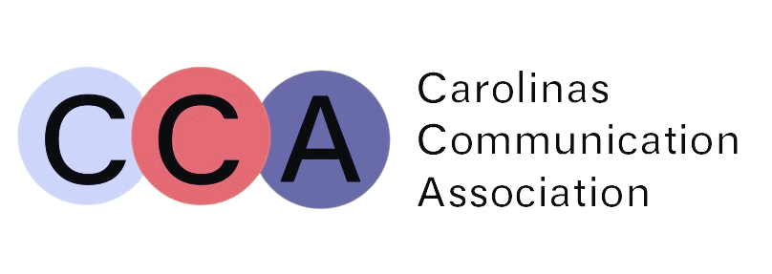
CCA 2023 Award Winners
Mônica Pombo Early Career Teaching Award
Dr. Vincent Russell, Western Carolina University

Lloyd Rohler Career Teaching Award
Dr. Kellie Roberts, University of Florida

Betty Jo Welch Award
Kim Cuny, University of North Carolina, Greensboro

Ray Camp Award
“Using Public Relations Theory to Communicate Across Differences: Expanding on Situational Theory of Publics to Account for Demographic and Social Differences Among Publics
L. Meredith Morgoch, Salisbury University
Hollie Smith, University of Oregon
Dean Mundy, University of Oregon

Mary E. Jarrard Graduate Paper
“Foodbanks on the Front Lines”: Reimagining Food Assistance through Organizational Tensions
Elaina Eakle, Ph.D. Candidate, University of North Carolina at Chapel Hill

Mary E. Jarrard Undergraduate Paper
“Facing My Own Misogyny”: A Rhetorical Analysis of Personal Essays on the Subreddit r/exredpill
AJ Siegel, The University of North Carolina at Charlotte

Top Gifts Award
“The Voice Over Project: How the need for Inclusion and Community led to the Perfect and Different Kind of G.I.F.T.”
Mr. George Buggs, III; Johnson C. Smith University
Jasmine M. Corbett, Johnson C. Smith University
Rhunette Corbett, Johnson C. Smith University
Markus Gray, Johnson C. Smith University
Tiphane Pate Johnson C. Smith University

